Batteries On-Orbit
Try to minimize the use of batteries whenever possible. Batteries are relatively heavy and we try to not fly up more than we need. Many batteries are flown up with specific uses and purposes planned out. Some are flown up as general use.
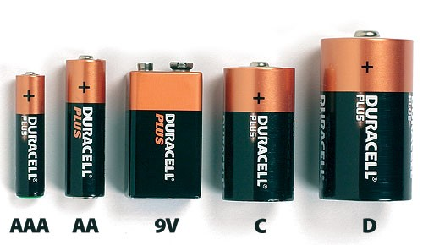
The Space Station has standard alkaline batteries for general use in a variety of equipment, tools, lights, microphones, and even musical instruments. This includes AAA, AA, C, D and 9V batteries. There are also some rechargeable--Makita 12V, De Walt 18V, and Canon video camera batteries (7.4V). 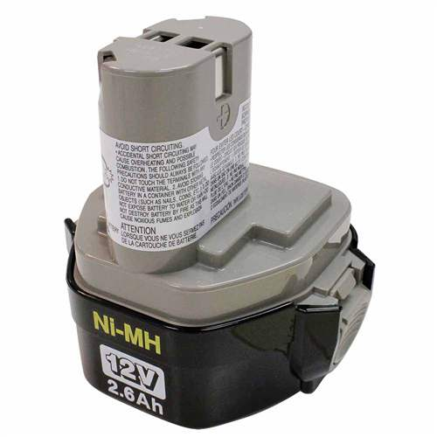
Mikita
